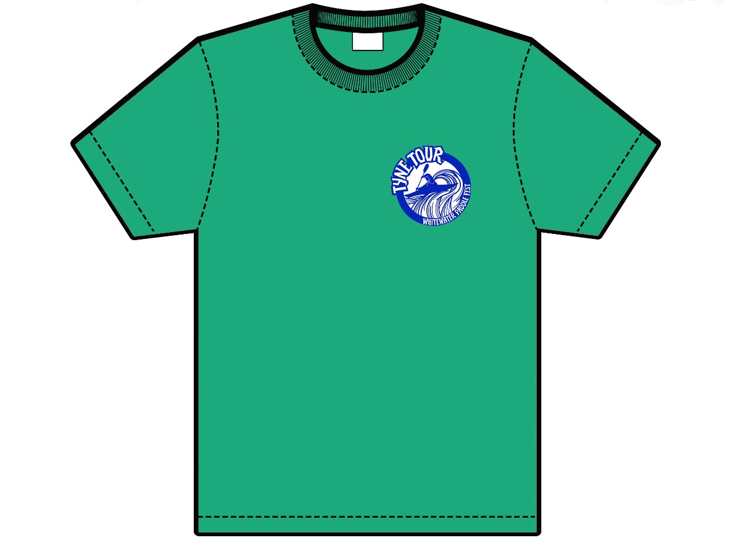

**Tyne Tour 2025 T-Shirts**

**£16 Each**

Please indicate your quantity and size below, as well as your personal details so we can get them to you over the weekend.

Please pay using the Bank Details at the bottom of this form.

Quantity: ______________

Size: __________________

Name: ____________________________

Email Address: ______________________________

Phone Number: _______________________________

Bank Details:

Hexham Tyne Tour

Account Number: 70791016

Sort Code: 20-40-09

Barclays Hexham

Please include your name as reference, pre orders are only valid with full payment

Please return completed forms to booking@tynetour.co.uk